**Experiment-3.1**

**Student Name:** YANA SRIVASTAVA **UID:** 20BCS2279

**Branch:** CSE **Section/Group:** 20BCS_WM-906**/**B

**Semester:** 5th **Subject Code:** 21CST-317

**Subject Name:** Machine learning lab

1. **Aim/Overview of the practical:** Implement Kmeans.
2. **Requirements**: Any Dataset for classification, Jupyter notebook or Google collab**.**

# Description/ Code:

**# importing all necessary libraries**

import pandas as pd

import matplotlib.pyplot as plt import seaborn as sns

from sklearn.cluster import KMeans

from sklearn.model_selection import train_test_split

# # Reading the data

df=pd.read_csv("3D_spatial_network.txt",names=['OSM_ID','LONGITUDE','LATITUDE','AL TITUDE'])

df.head()

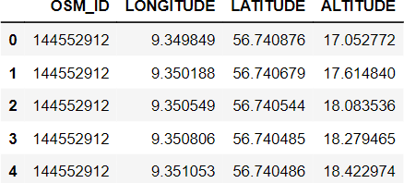

# # Preprocessing the data and Splitting the dataset into train and test

data = df.drop('OSM_ID',axis=1)

train_data,test_data = train_test_split(data,test_size=0.3) std_scaler = MinMaxScaler()

train_data['LONGITUDE']=train_data['LONGITUDE']/train_data['LONGITUDE'].max()

train_data['LATITUDE']=train_data['LATITUDE']/train_data['LATITUDE'].max() train_data['ALTITUDE']=train_data['ALTITUDE']/train_data['ALTITUDE'].max()

test_data['LONGITUDE']=test_data['LONGITUDE']/test_data['LONGITUDE'].max() test_data['LATITUDE']=test_data['LATITUDE']/test_data['LATITUDE'].max() test_data['ALTITUDE']=test_data['ALTITUDE']/test_data['ALTITUDE'].max()

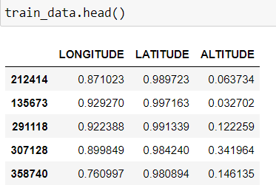

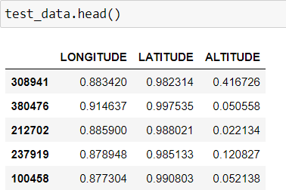

# **Training Kmeans model for clustering** clustering_Kmeans = KMeans(n_clusters=6) clustering_Kmeans.fit(train_data)

# **Predicting the test data for SVM** pred=clustering_Kmeans.predict(test_data) print(pred)

# # Clustering

plt.figure(figsize=(30,5)) plt.subplot(1,3,1)

sns.scatterplot(test_data['LONGITUDE'],test_data['LATITUDE'],hue=pred)

plt.subplot(1,3,2) sns.scatterplot(test_data['LONGITUDE'],test_data['ALTITUDE'],hue=pred)

plt.subplot(1,3,3) sns.scatterplot(test_data['LATITUDE'],test_data['ALTITUDE'],hue=pred)

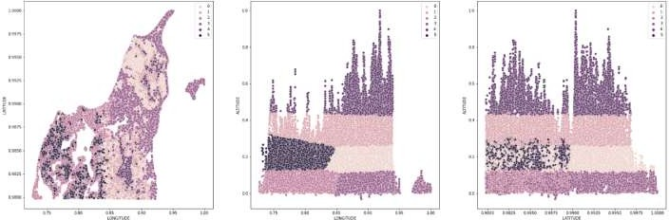

# Learning outcomes (What I have learnt):

* **Kmeans clustering**

**Evaluation Grid (To be created as per the SOP and Assessment guidelines by the faculty):**

|  |  |  |  |
| --- | --- | --- | --- |
| Sr. No. | Parameters | Marks Obtained | Maximum Marks |
| 1. |  |  |  |
| 2. |  |  |  |
| 3. |  |  |  |
|  |  |  |  |